Data Science and maintenance internship at-
International Institute of SDG's and Public Policy Research

Submitted in partial fulfilment of the requirements for the award of the degree of

Bachelor of Computer Applications



Submitted to
Ms. Shalini Bhartiya VSIT, VIPS
Submitted by Abhay (08117702023)

(Batch: 2023 – 2026)
Vivekananda Institute of Professional Studies – Technical Campus New Delhi - 110034

OFFER LETTER

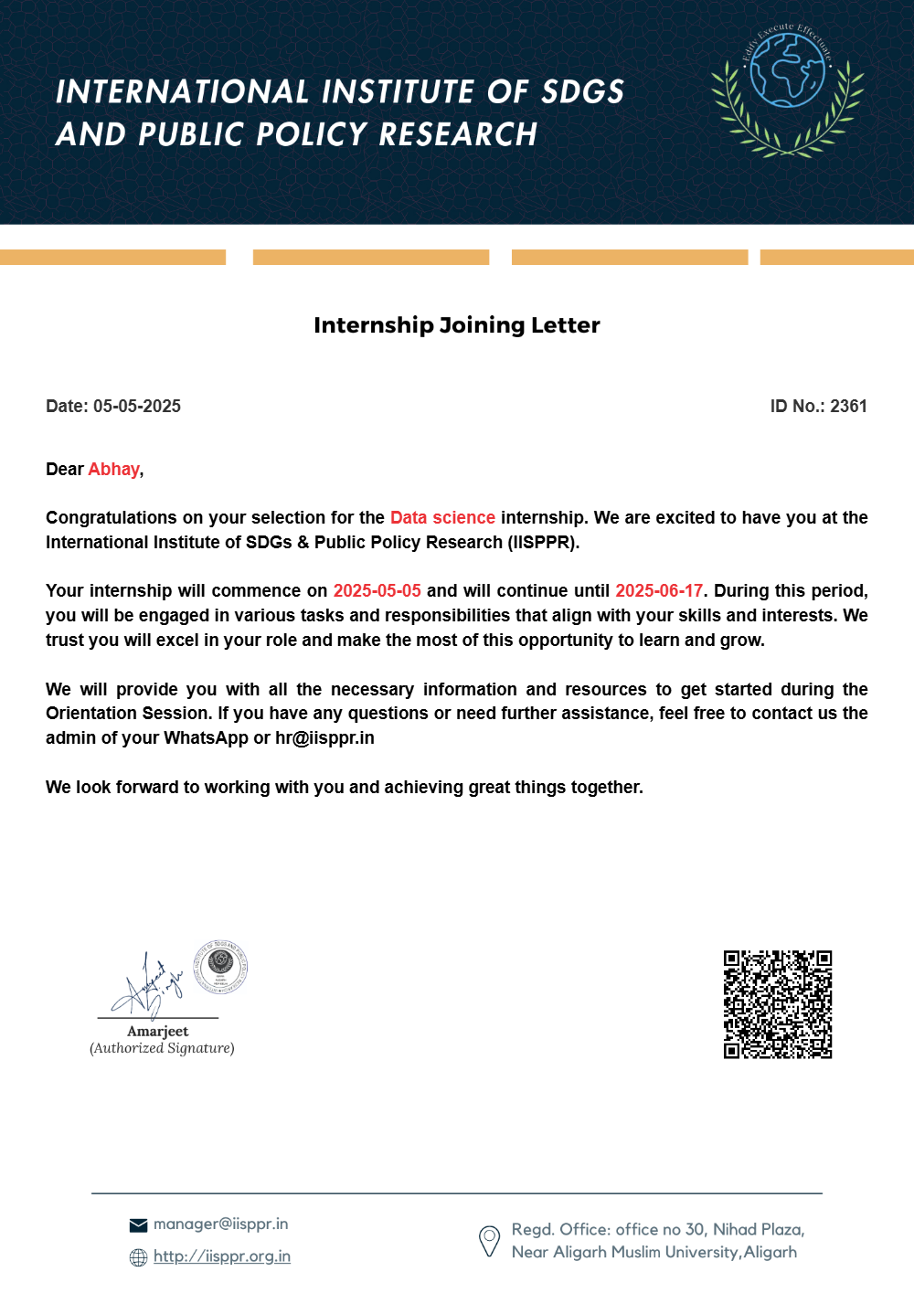
Self-certification

This is to certify that the internship report entitled “Data Science Internship at the International Institute of SDG’s and Public Policy Research” has been completed by me as part of my role as a Data Science Intern. The work presented in this report is an authentic record of the tasks, analyses, and responsibilities undertaken by me during the internship period and is submitted in partial fulfilment of the requirements for the award of the degree of Bachelor of Computer and Information Sciences (AI & ML + Data Science).

The contents of this internship report are based entirely on my original work, including data cleaning, exploratory data analysis (EDA), feature engineering, machine learning model development, hyperparameter optimization, and dashboard/report creation. To the best of my knowledge and belief, this report has not been submitted earlier for the award of any degree or diploma.

Abhay (08117702023) BCA 5B

Acknowledgment

I would like to express my sincere gratitude to the International Institute of SDG’s and Public Policy Research for giving me the opportunity to work as a Data Science Intern. This internship allowed me to deepen my practical understanding of data preprocessing, exploratory data analysis (EDA), feature engineering, machine learning model development, and real-world data-driven decision-making. I am thankful to all the team members for their continuous guidance, support, and willingness to assist whenever needed.

I also extend my appreciation to the entire data and research team for fostering a professional yet collaborative work environment. Their constructive feedback, mentorship, and consistent encouragement significantly enhanced the quality of my work and helped me grow throughout the internship duration.
A heartfelt thank you to my project supervisor for their constant guidance, motivation, and insightful feedback. Their support played a crucial role in helping me stay focused, improve my technical skills, and achieve my learning and project goals.

I would also like to express my sincere appreciation to my college, Vivekananda Institute of Professional Studies – Technical Campus, for providing an academic environment that encourages innovation, analytical thinking, and continuous learning. The institutional support has been instrumental in shaping my professional development.

Finally, I extend my gratitude to everyone who directly or indirectly contributed to my learning, growth, and the successful completion of this internship report.

Abhay (08117702023)

Abstract

This internship report outlines the work undertaken during my role as a Data Science Intern at the International Institute of SDG’s and Public Policy Research, where I was responsible for performing exploratory data analysis (EDA), data cleaning, feature engineering, model development, and generating analytical insights to support research-driven decision-making. In a data-centric environment, transforming raw datasets into meaningful and actionable insights is crucial for evidence-based policy formulation and effective reporting.

During the internship, I worked on a variety of analytical tasks, including preprocessing raw data, conducting statistical and visual exploration, engineering relevant features, and building machine learning models using advanced techniques such as XGBoost, LightGBM, and Random Forest. I also applied Bayesian Optimization using Optuna to fine-tune model performance and created clear, meaningful visualizations and reports to communicate insights to non-technical stakeholders. Additionally, I contributed to dashboard creation using Power BI to enable interactive and accessible data representation.

Overall, the internship enhanced my practical understanding of end-to-end data science workflows and improved my skills in analytical thinking, model optimization, data visualization, and professional documentation.

Chapter 1: PROBLEM FORMULATION

Introduction about the company
The International Institute of SDG’s and Public Policy Research is a dedicated research-driven organisation committed to advancing sustainable development, evidence-based policymaking, and data-centric analysis for societal impact. The institute works in alignment with the United Nations Sustainable Development Goals (SDGs), offering analytical insights, research support, and data-backed evaluations to government bodies, academic institutions, NGOs, and policy think tanks.
The organisation focuses on leveraging data science, public policy research, and advanced analytical frameworks to address pressing developmental challenges. Its work spans multiple domains such as health, education, climate action, economic growth, gender equality, and sustainable cities—ensuring that data and technology play a central role in shaping impactful public policies.
Supported by a diverse team of researchers, data analysts, public policy experts, and technology professionals, the institute emphasizes the integration of modern analytical tools—including statistical modeling, machine learning, and data visualization—to derive meaningful insights from complex datasets. The organisation’s mission is to empower institutions with accurate, research-backed information that supports transparent, ethical, and sustainable decision-making.

Introduction about the problem

In today’s data-driven environment, organisations increasingly rely on accurate, high-quality data to support research, policy formulation, and strategic decision-making. For an institute like the International Institute of SDG’s and Public Policy Research, where insights must be aligned with the Sustainable Development Goals (SDGs), ensuring clean, reliable, and well-structured datasets is essential.

The core problem arises from the dynamic and unstructured nature of real-world data. Raw datasets often contain missing values, outliers, inconsistencies, multicollinearity, and non-standard formats. These issues can significantly affect the accuracy of statistical models and machine learning algorithms. Additionally, research teams frequently request updated analyses, visualizations, and model outputs, which require the data to be continually cleaned, processed, and fine-tuned.

To address these challenges, organisations depend on a structured and methodological data science process that includes cleaning, exploration, modeling, and validation. During my internship, my responsibilities were aligned with this requirement. The key objectives involved:

- performing exploratory data analysis (EDA) to identify patterns and data issues,
- conducting data cleaning to transform raw datasets into structured formats suitable for modeling,
- executing feature engineering to enhance model performance and address multicollinearity,
- building and optimizing machine learning models using XGBoost, LightGBM, and Random Forest,
- applying Bayesian Optimization (Optuna) for efficient hyperparameter tuning,
- and developing visualizations and Power BI dashboards to communicate insights clearly.

Through this workflow, the goal was to generate accurate, insightful, and research-driven outcomes that support the institute’s mission of promoting sustainable development through reliable data analysis.

Present state of the Art
Modern organisations increasingly depend on data-driven insights to support research, evaluate outcomes, and guide strategic policymaking. As a result, data science has evolved into an integral component of institutional decision-making. Today, most research and policy-focused institutions rely on advanced analytical tools, automated workflows, and machine learning frameworks to extract meaningful patterns from large, complex datasets.
Contemporary data science practices involve the use of technologies such as Python, Pandas, NumPy, Scikit-learn, Matplotlib, Seaborn, XGBoost, LightGBM, and hyperparameter optimization libraries like Optuna. These tools provide efficient methods for cleaning data, performing statistical analysis, engineering features, training models, and validating outcomes. Additionally, dashboarding solutions like Power BI enable teams to translate analytical results into interactive visual formats that stakeholders can easily interpret.
Despite these advancements, modern data pipelines also come with certain challenges. Real-world datasets are often messy, incomplete, inconsistent, or collected from multiple sources with varying formats. This increases the dependence on data scientists to manually perform key tasks such as:
- cleaning and preprocessing raw datasets,
- resolving multicollinearity and missing data,
- identifying meaningful features,
- selecting and tuning appropriate machine learning model.

Need for Computerization

In modern research and policy-driven organisations, handling large volumes of raw data manually is neither practical nor reliable. Real-world datasets often contain missing values, inconsistencies, duplicates, and complex patterns that require systematic processing. If these tasks were executed manually using spreadsheets or non-standardized methods the process would become extremely time-consuming, error-prone, and difficult to scale.

Computerized data science tools and automated workflows address these challenges by providing structured, repeatable, and efficient mechanisms for data handling. Technologies such as Python, Pandas, Scikit-learn, Optuna, and Power BI enable organisations to:
- clean and preprocess data with precision,
- perform large-scale exploratory data analysis (EDA),
- engineer meaningful features to enhance model accuracy,
- develop and fine-tune machine learning models efficiently,
- and visualize results using dashboards and analytical reports.

By relying on computerization, organisations ensure accuracy, reduce human dependency for repetitive tasks, and maintain consistency across analyses. Automated libraries for model training and hyperparameter tuning significantly reduce effort while improving the quality and reliability of insights.

Proposed work

The proposed work for this internship focused on supporting the institute’s data-driven research and analytical requirements. As the organisation frequently handles diverse datasets aligned with various Sustainable Development Goals (SDGs), a structured approach was essential to ensure that these datasets were cleaned, analyzed, modeled, and interpreted accurately.

My role contributed to this requirement by participating directly in the end-to-end data science workflow. The proposed work involved:
- receiving raw datasets from research teams,
- cleaning and preprocessing the data to resolve errors, missing values, and inconsistencies,
- conducting exploratory data analysis (EDA) to understand trends and patterns,
- performing feature engineering to enhance the effectiveness of predictive models,
- building machine learning models using XGBoost, LightGBM, Random Forest,
- applying Bayesian Optimization (Optuna) to improve model performance,

This structured workflow ensured that research outputs were analytically sound, visually clear, and aligned with the institute’s ongoing projects and policy objectives. By following a systematic data science approach cleaning data, optimizing models, interpreting findings, and preparing detailed reports the work contributed to producing reliable insights that support sustainable development research.

Importance of the work
The work carried out during this internship plays a significant role in enhancing the accuracy, reliability, and overall effectiveness of the analytical outputs produced by the International Institute of SDG’s and Public Policy Research. As the organisation relies heavily on data-driven insights to support research studies, policy evaluations, and SDG-aligned initiatives, ensuring that datasets are properly cleaned, analyzed, and modeled is essential for maintaining credibility and impact.
Timely data preprocessing, exploratory data analysis, and model development allow the organisation to derive meaningful insights from raw information without delay. By applying structured data science methodologies, the work ensures that analytical findings are both accurate and aligned with the expectations of research teams and external stakeholders such as policymakers, NGOs, and academic partners. This prevents misinterpretation of data, reduces analytical inconsistencies, and supports evidence-based decision-making.
Through contributions such as feature engineering, machine learning model optimization, and the creation of insightful visualizations and dashboards, the internship work directly strengthens the institute’s research capabilities. These outputs make complex datasets easier to understand, improve the clarity of insights, and enhance the organisation’s ability to communicate data-driven conclusions effectively.
Ultimately, the work contributes to producing high-quality analytical results that support sustainable development research, inform public policy discussions, and empower organisations to make informed decisions based on reliable data. This aligns closely with the institute’s broader mission of advancing data-backed solutions for societal challenges.

Chapter 2: SYSTEM ANALYSIS

Feasibility Study

A feasibility study evaluates whether the data science tasks performed during the internship can be effectively supported by the institute’s existing technical infrastructure, organisational capabilities, and operational processes. It ensures that all analytical activities—including data cleaning, EDA, feature engineering, model building, optimization, and visualization—are practical, efficient, and aligned with the research-oriented objectives of the International Institute of SDG’s and Public Policy Research.

Technical feasibility

The tasks performed during the internship were technically feasible because the organisation uses a modern, robust, and industry-standard data science environment. The existing technical setup provided sufficient tools and resources for performing end-to-end data analysis.
The following technologies enabled smooth execution of the internship tasks:

- Python ecosystem (Pandas, NumPy, Scikit-learn) for data cleaning, preprocessing, and exploratory data analysis.
- XGBoost, LightGBM, and Random Forest for high-performance machine learning model development.
- Optuna for efficient Bayesian hyperparameter optimization.
- Jupyter Notebook / IDE for experimentation and iterative analysis.
- Power BI for developing interactive dashboards and visual summaries.
- Matplotlib and Seaborn for generating detailed analytical visualizations.
These tools provided a stable environment for handling raw datasets, applying data transformations, training ML models, and validating results. The availability of libraries for feature engineering, modeling, and evaluation ensured that the technical execution of tasks was not only feasible but highly efficient.

Economic Feasibility

The work performed during the internship is economically feasible due to the organisation’s reliance on free, open-source, and cost-efficient technologies. Using open-source tools minimizes the need for expensive enterprise-level software while still enabling high-quality analysis.
Key economic advantages include:

- Python, Scikit-learn, Pandas, NumPy, Optuna, Matplotlib, and Seaborn are entirely open-source with no licensing costs.
- The machine learning workflow does not require high-cost proprietary modeling tools.
- Power BI (free or low-cost version) provides an economical dashboarding solution.
- Intern involvement helps reduce workload on senior analysts without increasing major overhead expenses.
- Cloud or local computational resources used for the internship involve minimal additional cost.

These factors make the entire data science workflow cost-effective, scalable, and sustainable for the organisation. By leveraging open-source ecosystems and structured workflows, the institute ensures maximum output with minimal financial investment.

Operational Feasibility
The workflow followed during the internship aligned well with the organisation’s existing analytical and research operations.

Operational feasibility was ensured through the following factors:
- Python-based workflows enabled easy execution of data cleaning, EDA, feature engineering, and modeling tasks.
- The research and data teams follow clear communication channels, making coordination for dataset understanding and requirement gathering simple.
- Tools like Jupyter Notebook and Power BI provided user-friendly environments for documentation, analysis, and visualization.
- Machine learning tasks including model building and optimization—were operationally manageable within the available computational resources.

The low learning curve, systematic workflow, and well-established internal processes ensured that all analytical activities during the internship could be executed efficiently and without disruption to ongoing research work.

Other Feasibility Dimensions
- Legal Feasibility

The work performed during the internship adhered fully to legal and ethical data-handling standards.
- All datasets used were owned or licensed by the organisation.
- No third-party copyrighted or restricted data was accessed.

Social Feasibility
The analytical work carried out during the internship contributes positively to the organisation’s social and research-driven goals.
- Stakeholders (researchers, policymakers, NGOs) gain clear, accurate, and updated insights into SDG-related issues.
- Clean and well-analyzed datasets improve communication and help teams make informed, socially relevant decisions.
- Visualizations and dashboards enhance the accessibility of complex information, benefiting both internal and external audiences.

Analysis Methodology

The analysis methodology defines the systematic approach followed during my Data Science internship at the International Institute with SGDS. The work primarily involved data collection, preprocessing, analysis, visualization, model development, and documentation. A structured methodology was essential to ensure accuracy, reliability, and meaningful insights from the datasets used during the internship.

1. Requirement Gathering
The first step involved understanding the problem statement or analytical objective provided by mentors and project coordinators:
- identifying the purpose of the analysis (e.g., prediction, classification, trend analysis, visualization),
- understanding the type of data required,
- collecting details about metrics, KPIs, or outputs expected,
- discussing constraints, timelines, and reporting format.
Clear communication ensured that the data science tasks aligned with the institute’s research goals and SGDS’s analytical needs.

2. Data Collection & Understanding
Once requirements were finalized, relevant datasets were collected from:
- internal databases,
- publicly available sources,
- academic datasets provided by mentors,
- CSV, Excel, JSON, or API-based formats.
The dataset was studied to understand:
- number of features and observations,
- data types,
- distributions,
- missing values,

This step helped determine whether the data was suitable for the intended analysis.

3. Data Cleaning & Preprocessing
Data was prepared for analysis through systematic preprocessing steps such as:
- handling missing values,
- removing duplicates,
- encoding categorical variables,
- feature scaling or normalization,

Proper preprocessing ensured clean, consistent data which is crucial for building reliable analytical models.

4. Exploratory Data Analysis (EDA)
EDA was conducted using Python libraries such as Pandas, NumPy, Matplotlib, and Seaborn to:
- identify trends and patterns,
- analyze distributions,
- detect correlations,
- visualize insights using graphs, heatmaps, charts, and plots.
This step helped build a deeper understanding of the dataset and guided decisions for feature selection or model selection.

5. Model Development / Statistical Analysis
Depending on the project requirements, appropriate models or analytical techniques were applied, such as:
- regression models,
- classification models,
- clustering techniques,
- time-series forecasting,
- statistical hypothesis testing.
Models were evaluated using standard metrics such as accuracy, precision, recall, RMSE, MAE, F1-score, or R² score.
This step transformed raw data into actionable insights or predictive capabilities.

6. Visualization & Insight Generation
Results were translated into meaningful visualizations and dashboards using:
- Matplotlib
- Seaborn
- Plotly
- Power BI / Tableau (if required)
These visualizations helped communicate insights clearly to mentors and stakeholders, making the findings easy to interpret.

7. Documentation & Reporting

Every stage of analysis—from data collection to final insights—was documented systematically:
- code notebooks (Jupyter/Colab),
- data preprocessing steps,
- EDA observations,
- model performance summaries,
- conclusions and recommendations.
This ensured transparency, reproducibility, and clarity in the entire analytical workflow.

8. Review & Final Presentation
After completing the analysis:
- results were reviewed by mentors,
- necessary corrections or improvements were made,
- final findings were presented in report/presentation format.

    - Software used

Software component | Tool/Technology | Purpose in the internship
Programming Environment | Python | Writing code for EDA, data cleaning, feature engineering
Data Processing Libraries | Pandas, NumPy | Handling datasets, cleaning data, performing transformations
Visualization Tools | Matplotlib, Seaborn, Plotly | Creating charts, graphs, and visual insights for reports
Machine Learning Libraries | Scikit-learn, XGBoost, LightGBM | Building, training, evaluating, and comparing machine learning models.
Optimization Framework | Optuna | Hyperparameter tuning
Dashboarding / Reporting | Power BI / Tableau | Creating interactive dashboards
Version Control | Git / GitHub | Maintaining code versions, collaboration, and documentation of work

    - Hardware used

Hardware component | Tool/Specification | Purpose in the internship
Development machine | Standard laptop, Windows 11, Intel i5, 16 GB RAM | Running Python scripts, executing Jupyter notebooks, performing EDA, training ML models, and handling medium-sized datasets efficiently.
Storage Medium | Local Storage / Cloud Drive (Google Drive / OneDrive) | Storing datasets, saving cleaned data, maintaining model files, visualizations, and backup notebooks.
Internet connection | Stable broadband | Accessing online resources, downloading datasets, running cloud notebooks (Colab), syncing GitHub repositories, and communicating with mentors.

Chapter 3: SYSTEM DESIGN

Design methodology
The data science workflow followed during the internship was based on a structured and systematic methodology to ensure that every analytical task—whether related to EDA, feature engineering, model development, or reporting—was executed accurately, efficiently, and in alignment with the organisation’s research objectives.

Key Design Principles:

• Modularity: Each stage of the project—data cleaning, feature engineering, modelling, optimization, and visualization—was handled as an independent module. This separation ensured clarity, reduced errors, and made the workflow reusable for different datasets and research problems.

• Reproducibility: All experiments were conducted using Python notebooks, version-controlled scripts, and parameterized pipelines.
This allowed models, analyses, and visualizations to be reproduced or refined at any stage.

• Data-Centric Approach: The workflow prioritized understanding the structure, distribution, and quality of datasets through deep exploratory data analysis. Insights from EDA guided decisions on preprocessing, feature creation, and modeling strategies.

• Model Performance Optimization: Advanced techniques such as ensemble learning (XGBoost, LightGBM, Random Forest) and Bayesian Optimization through Optuna were used to significantly improve model accuracy and minimize error metrics.

Database design
Although much of the work during the internship focused on EDA, modelling, and visualization, all tasks were supported by structured data storage systems. The datasets used for analysis were stored in organized formats such as CSV, Excel, and SQL tables, depending on the source of the data.
The underlying database or data storage structure ensured:

• Structured Data Storage: Data was stored in tabular formats with clear relationships between variables, enabling seamless ingestion into Python for cleaning and analysis.

• Separation of Raw & Processed Data: Raw datasets, cleaned datasets, engineered features, and trained models were stored separately to maintain a clean and traceable workflow.

• Dynamic Data Handling: Data manipulation libraries such as Pandas and NumPy enabled efficient transformations, filtering, merging, and aggregation.

Data flow Diagram (level 0 DFD)

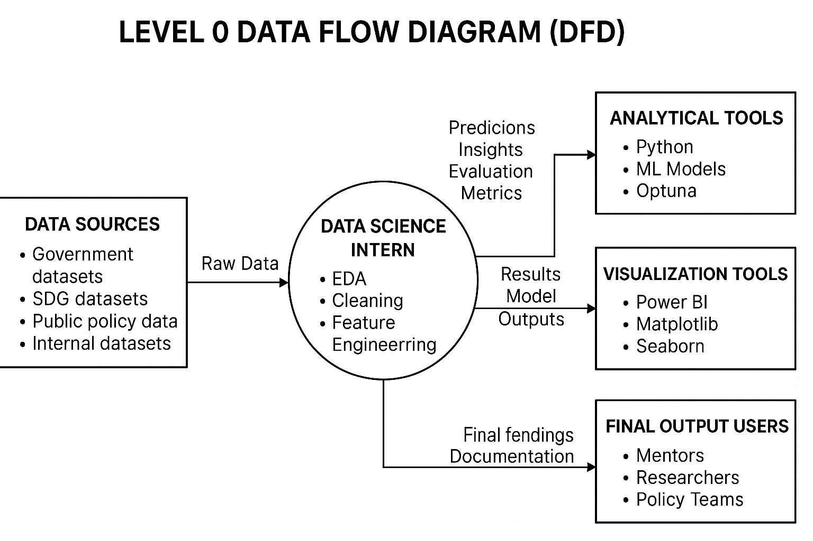

• Data Source → provides raw datasets
Government datasets, public policy datasets, SDG data repositories, or internally collected datasets.

• Data Science Intern (You) → performs EDA, cleaning, feature engineering, model building, and optimization
Using Python, ML algorithms, and optimization frameworks.

• Analytical Tools → (Python, ML models, Optuna) process and transform the data
Produce insights, predictions, and evaluation metrics.

• Visualization & Reporting Tools → Power BI, Matplotlib, Seaborn
Used to generate dashboards, charts, and research-oriented visual summaries.

• Final Outputs → shared with mentors, researchers, and policy teams
Supporting SDG-related decision-making and research activities.

E-R Diagram

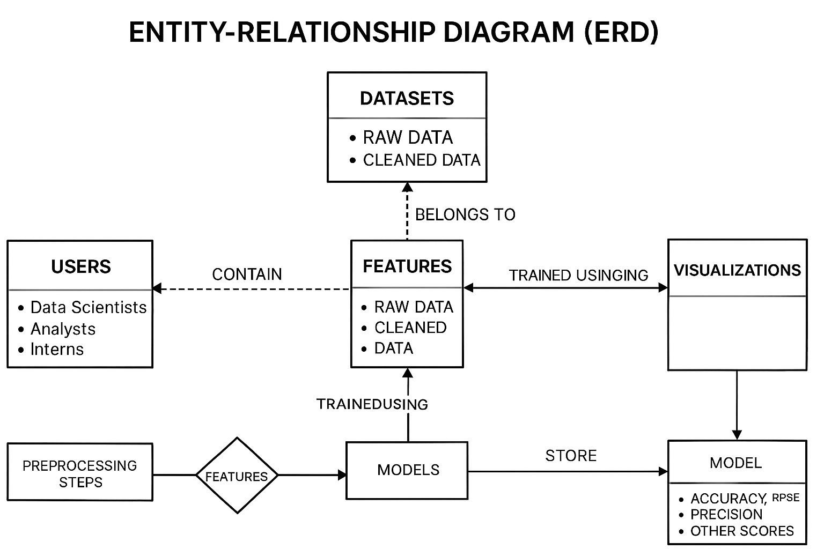

The ERD represents the key data components involved in the analytics and machine learning workflows during the internship. It shows how Datasets are connected to Features, Preprocessing Steps, Models, and Evaluation Metrics.

- Users (data scientists, analysts, interns) interact with datasets.
- Datasets contain raw or cleaned data used for modeling.
- Features belong to datasets and represent engineered attributes.
- Models are trained using these features.
- Evaluation Metrics store accuracy, precision, RMSE, or other scores.
- Visualizations are generated using model outputs or processed datasets.

This simplified ERD highlights how datasets, features, models, and metrics connect together, reflecting the typical structure of a data science workflow used during the internship.

Input Design

Input design refers to the information and datasets required to perform data analysis, preprocessing, visualization, and machine learning tasks during the internship. These inputs guided model development, exploratory analysis, and dashboard creation.

Types of Inputs Received

• Dataset Inputs:Raw CSV, Excel, or database records received from the team, containing fields such as:
- user behavior logs
- product/transaction data
- survey responses
- real-estate/healthcare/marketing datasets (as per project)

• Business Requirements:Guidelines from supervisors explaining:
- analysis goals
- KPIs to extract
- insights needed
- prediction targets

• Feature Inputs:Defined attributes required for modeling, such as:
- numerical features
- categorical encodings

Output design

Output design focuses on how processed data, visualizations, dashboards, and machine learning results were delivered during the internship.

Types of Outputs Produced

• Cleaned and Preprocessed Data:Final datasets after:
- missing value imputation
- encoding
- normalization
- feature engineering

• Exploratory Data Analysis (EDA):Charts, distributions, correlations, and summary statistics shared with the team.

• Machine Learning Model Outputs:
- prediction results
- classification reports
- confusion matrices
- RMSE, accuracy, precision, recall, F1-score

• Visual Dashboards:Interactive dashboards created using:
- Power BI
- Tableau
- Streamlit
- Matplotlib/Plotly visualizations

• Reports and Insights:PDF/Slides summarizing:
- insights found in the data
- important trends
- recommendations

Code Design and Development

The code design and development focused on building robust data pipelines, implementing preprocessing workflows, training ML models, and creating analytical dashboards.

Development Approach Used

• Modular Jupyter Notebook / Python Scripts:
Code was structured into clear sections:
- Data Loading
- Preprocessing
- Feature Engineering
- Model Training
- Evaluation
- Visualization

• Use of Standard Libraries:
During the internship, core Python libraries were used:
- pandas for data manipulation
- NumPy for numerical operations
- Matplotlib / Plotly / Seaborn for visualization
- Scikit-learn for ML model development
- Streamlit for dashboard/web UI (if applicable)

• Preprocessing Functions:
Reusable functions were created for:
- encoding
- scaling
- outlier removal
- missing value handling

• Model Training and Tuning:
Models were developed and optimized using:
- GridSearchCV / RandomizedSearchCV
- Cross-validation
- Evaluation metrics

• Versioned Pipeline:
Dataset versions and model versions were tracked to ensure:
- reproducibility
- comparison of multiple model runs

• Documentation and Comments:
Each code block included documentation explaining:
- the logic
- parameters used
- expected output

• Testing and Validation
- Code was executed step-by-step to detect errors.
- Model performance was validated on test data.
- Visualizations were checked for correctness and clarity.

Chapter 4: TESTING AND IMPLEMENTATION

Testing Methodology

The testing methodology followed during the internship focused on ensuring that all data preprocessing steps, visualizations, analytical reports, and machine learning models were accurate, reliable, and aligned with the project requirements.
Since data science workflows involve multiple stages data collection, cleaning, transformation, modeling, and visualization testing played a critical role in validating data quality and verifying correctness at every stage.
The testing process ensured:
- Clean and consistent datasets
- Correct implementation of preprocessing pipelines
- Accurate model outputs
- Valid evaluation metrics
- Proper functioning of dashboards or scripts
- Reproducible results across multiple runs

Testing was performed through a mixture of unit testing, integration testing, model testing, and validation using evaluation metrics.

Unit Testing
Unit testing validated the smallest components of the data science workflow.
This included verifying:
- Data loading scripts
- Missing value handling
- Outlier detection functions
- Encoding/scaling transformations

Module Testing
Module testing involved evaluating entire sections or components of the website that were updated:
      - Full preprocessing pipeline
      - Exploratory data analysis (EDA) module
      - Model training module
      - Visualization module

Integration Testing

Integration testing checked whether different modules worked together smoothly as one complete system.

Focus areas:

Preprocessing → Feature Engineering → Model Training

Model Training → Evaluation → Visualization

Data → Dashboard → User Interactions

Integration tests ensured:

No missing columns between stages

No datatype mismatches

Models accepted the processed data

Pipelines executed without breaking

System Testing
System testing validated the entire data science workflow end-to-end.
This included:
- Running the complete pipeline from raw data to final prediction
- Generating visuals and summary reports
- Testing performance on the full dataset
- Ensuring that outputs matched business requirements

White Box & Black Box Testing
Used when testing code logic inside preprocessing scripts or ML models.
Included:
- Reviewing Python functions
- Checking conditional logic in feature engineering
- Verifying algorithm implementation
- Ensuring correct shapes/types for input arrays
Black Box Testing:
Focused on the final output, without checking internal code.
Included:
- Running the pipeline and checking final cleaned dataset
- Validating model predictions from a user perspective
- Checking dashboard outputs as a typical user

Acceptance Testing
Acceptance testing ensured the final results matched expectations from supervisors or project mentors.
This included:
- Reviewing visualizations and insights
- Confirming model accuracy met required thresholds
- Ensuring that final reports answered the problem statement
- Checking that dashboards displayed correct KPIs
- Getting approval before final submission

Test data and Test cases
Testing the data science workflow required preparing structured test data and running defined test cases to validate preprocessing, modeling, and visualization outputs.
Test data included:
  - Raw datasets provided by the organisation
  - Sample records for testing transformations
  - Synthetic data created to validate edge cases
  - Multiple datasets for training/testing splits
Below are sample test cases adapted to a Data Science Internship:
Test Case 1: Data Preprocessing Check
  - Input: Raw dataset with missing values
  - Expected Output: Cleaned dataset with correct imputation
  - Result: Working as expected
Test Case 2: Feature Engineering Validation
  - Input: Numerical/categorical features
  - Expected: Correct encoding, scaling, feature creation
  - Result: Verified

Test Case 3: Model Training Test
  - Input: Processed dataset with labels
  - Expected: Model trains successfully without errors
  - Result: Verified

Test Case 4: Evaluation Metrics Check
  - Input: Predictions vs. actual values
  - Expected: Correct accuracy/RMSE/precision/recall
  - Result: Working fine

Implementation

The implementation phase during my Data Science internship at SGDS involved deploying the approved data updates, analytical insights, dashboards, and model outputs into the organisation’s internal systems and reporting workflows. The goal was to ensure that data-driven results were correctly integrated, visually clear, and aligned with the requirements shared by the project leads and domain experts.
Implementation was done in a structured, step-by-step manner to guarantee accuracy, consistency, and smooth integration of all data-related components.

Implementation Steps

• Data Cleaning & Pre-processing Deployment
Cleaned datasets—including processed numerical values, encoded variables, imputed missing values, and engineered features—were integrated into the project pipeline.
This ensured that downstream analysis, dashboard visuals, and models worked on accurate, refined data.

• Model Output Integration
Where predictive models or analytical scripts were used:
- Updated predictions were exported and integrated into dashboards
- Evaluation metrics (accuracy, precision, recall, RMSE, etc.) were updated
- Feature importance and statistical summaries were incorporated into reports
The focus was on maintaining accuracy and consistency across all outputs.

• Dashboard & Visualization Implementation
Using tools such as Power BI / Tableau / Python dashboards (Matplotlib/Seaborn/Plotly), updated visualizations and analytical insights were added:
- New graphs and charts were embedded into dashboards
- Filters and slicers were updated to reflect new data categories
- Visual elements were optimized for clarity, readability, and professional presentation

• Automation Script Deployment
Python scripts responsible for:
- Data extraction
- Data transformation
- Report generation
were updated and re-run after changes were approved.
Where applicable, the scripts were version-controlled and tested before re-deployment.

• Review & Approval
Before deployment:
- Insights were verified with mentors and the data team
- Visualizations were rechecked for clarity
- Model outputs were validated against expected results
- A final preview was shared with the SGDS team for confirmation
Only after approval were the updates integrated into the final dashboards or reporting system.

• Post-Deployment Verification
After implementation, final validation included:
- Checking dashboards for rendering issues
- Ensuring charts loaded correctly on all devices
- Confirming that data was up-to-date and error-free
- Revalidating model outputs after deployment
- Ensuring no broken elements, missing visuals, or incorrect metrics appeared

Chapter 5: CONCLUSION AND REFERENCES

Conclusion
The internship at SGDS provided a structured, hands-on, and industry-oriented understanding of how real-world data science workflows are carried out in a professional environment. Throughout the internship, I worked on data cleaning, exploratory data analysis, dashboard creation, and model development, which strengthened my ability to transform raw data into meaningful, actionable insights.
By collaborating closely with the internal data team, business team, and project mentors, I gained a deeper understanding of how organizations rely on data-driven decision-making. The internship demonstrated how data is collected, processed, validated, and finally used to generate insights that support business goals. Every task—whether building visualizations, performing statistical analysis, or developing predictive models—helped improve my understanding of end-to-end data workflows.
A major highlight was learning how to structure datasets, validate outputs, optimize visual dashboards, and ensure that insights are accurate, reliable, and easy for stakeholders to interpret. The experience also enhanced my technical skills in Python, SQL, Excel, Power BI/Tableau, data preprocessing techniques, and ML model evaluation.
Overall, the internship successfully showcased the importance of a disciplined and analytical approach to data. It strengthened my ability to handle real-world datasets, collaborate within a team, communicate insights effectively, and apply data science techniques to solve practical business problems. This experience forms a strong foundation for my future career in Data Science, Analytics, and Machine Learning.

System Specification

The data science tasks carried out during the internship were supported by a standard development environment consisting of commonly used analytical tools, open-source libraries, and cloud-based platforms. The system setup enabled efficient data preprocessing, model development, and dashboard creation.

System Architecture Overview:
• Data Collection & Storage
- Datasets stored in CSV, Excel, SQL databases, or internal drives
- Cloud storage used where needed for shared data access
- Structured and unstructured data managed through organized folders

• Data Processing Environment
- Python used for data cleaning, preprocessing, feature engineering
(Pandas, NumPy, Scikit-learn, Matplotlib, Seaborn)
- Jupyter Notebook / VS Code used for running scripts and analytical workflows
- SQL used for querying and preparing datasets from relational databases

• Analytics & Dashboarding
- Power BI / Tableau used for interactive dashboards
- Matplotlib / Plotly used for custom visualizations
- Dashboards published and reviewed with internal teams

• Model Development & Evaluation
- Machine learning models implemented using
Scikit-learn, Logistic Regression, Decision Trees, Random Forest, etc.
- Model evaluation done using metrics like
Accuracy, Precision, Recall, F1-score, RMSE, Confusion Matrix

• Hardware
- Standard development laptop:
Windows 11, Intel i5/i7, 8–16 GB RAM
- Sufficient for data analysis, ML model training, and dashboard creation

• Collaboration Tools
- Google Workspace / Slack / Teams used for task updates and communication
- Version management and file sharing done through shared drives or Git.

    - Hardware requirement

Hardware component | Tool/Specification | Purpose in the internship
Development machine | Standard laptop, Windows 11, Intel i5, 16 GB RAM | Running Python scripts, executing Jupyter notebooks, performing EDA, training ML models.
Storage Medium | Local Storage / Cloud Drive (Google Drive / OneDrive) | Storing datasets, saving cleaned data, maintaining model files, visualizations, and backup notebooks.
Internet connection | Stable broadband | Accessing online resources, downloading datasets

    - Software requirement

Software component | Tool/Technology | Purpose in the internship
Programming Environment | Python | Writing code for EDA, data cleaning, feature engineering
Data Processing Libraries | Pandas, NumPy | Handling datasets, cleaning data, performing transformations
Visualization Tools | Matplotlib, Seaborn, Plotly | Creating charts, graphs, and visual insights for reports
Machine Learning Libraries | Scikit-learn, XGBoost, LightGBM | Building, training, evaluating, and comparing machine learning models.
Optimization Framework | Optuna | Hyperparameter tuning
Dashboarding / Reporting | Power BI / Tableau | Creating interactive dashboards
Version Control | Git / GitHub | Maintaining code versions, collaboration, and documentation of work

  - Limitations of the System
Despite the effectiveness of the data science workflow used during the internship, certain limitations were observed while working with datasets, dashboards, and models:
• Limited Access to Production Data
As an intern, access to fully detailed or sensitive datasets was restricted due to data privacy policies. This limited exposure to real production-level data complexity.
• Dataset Quality Issues
Some datasets contained missing values, duplicate entries, inconsistent formatting, and unbalanced classes, which required extensive preprocessing.
• Manual Data Cleaning
A large part of data preprocessing—handling null values, formatting errors, outliers—was performed manually, increasing time consumption and chances of human oversight.
• Limited Computing Resources
The development machine had limited CPU/RAM, which restricted:
- training heavy ML models,
- running large datasets,
- performing high-complexity computations.
• No Automated Pipelines
Data ingestion, cleaning, feature extraction, and model retraining were mostly manual processes with no CI/CD or automated pipelines.
• Dashboard Refresh Limitations
Dashboard updates (Power BI/Tableau) required manual refreshes and periodic exports rather than automated scheduling.
.

Future Scope for Modification

The data science workflow implemented during the internship provides room for multiple enhancements that can improve automation, accuracy, and the reliability of insights.

• Automated Data Pipelines
Develop ETL pipelines using:
- Airflow
- Prefect
to automate data collection, cleaning, transformation, and model updates.

• Model Deployment & MLOps
Introduce full MLOps work flow:
- CI/CD pipelines for ML
- Automated model retraining
- Monitoring model drift
- Deploying models using FastAPI or Docker
This ensures continuous improvement and production-level reliability.

• Advanced Visualization Dashboards
Enhance dashboards using:
- automated refresh through Power BI gateway
- interactive components
- real-time analytics dashboards using Streamlit or Dash

• Cloud Integration
Shift storage and computation to cloud platforms (AWS, GCP, Azure) for:
- scalable processing
- faster model training
- centralized dataset handling

References / Bibliography

- International Institute of SDG's and Public Policy Research – Official Website
https://iisppr.org.in/
Used for understanding company information, product ecosystem, and workflow structure.

- Python Official Documentation – Core Programming & Data Handling
https://docs.python.org/
Used for understanding Python syntax, libraries, and data structures.

- NumPy Documentation – Numerical Computing
https://numpy.org/doc/
Referenced for array operations, mathematical functions, and efficient data manipulation.

- Pandas Documentation – Data Analysis & Preprocessing
https://pandas.pydata.org/docs/
Used for data cleaning, transformation, exploratory data analysis (EDA), and feature engineering.

- Matplotlib & Seaborn Documentation – Data Visualization Tools
https://matplotlib.org/stable/
https://seaborn.pydata.org/
Used for plotting graphs, visualizing trends, and generating insights.

- Scikit-Learn Documentation – Machine Learning Algorithms
https://scikit-learn.org/stable/
Referenced for implementing classification, regression, clustering, model evaluation, and preprocessing techniques.

